# Manual for PHP, Composer, PHPUnit

▪ **Setting up PHP--**

1. Click on this [link](https://windows.php.net/downloads/releases/php-8.0.2-Win32-vs16-x64.zip) to download the PHP zip file and then unzip the file and copy the files inside that zip to the “**C drive**” by creating a new folder named after “**php-version**”.
2. Later on, copy the path of that folder and add it to the System variable “**path**”.

Edit the system environment variable>Environment variables>System variables>Double click on “Path”>New>Paste the copied path here>Press OK>Press OK>Done!

▪ **Setting up Composer –**

1. Click on this [link](https://getcomposer.org/Composer-Setup.exe) to download the executable Composer installation file and run it.
2. Write “**composer**” in the in CMD (Command Prompt) for successful installation confirmation.

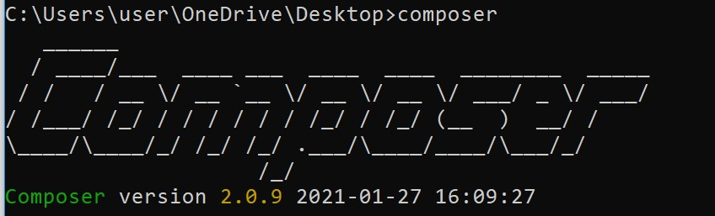

▪ **Setting up PHPUnit –**

1. Create a new folder for your project, I named mine as "phpunit".
2. Navigate to the created folder in CMD (Command Prompt). For example, if your project folder is in Desktop, simply write and run "**cd desktop**" or just copy the path from the address bar of your project directory and then type "**cd project_folder_name**". To illustrate, in my case it is "**cd phpunit**").
3. Once in the directory within CMD write the following to install PHPUnit in that particular directory "composer require phpunit/phpunit".

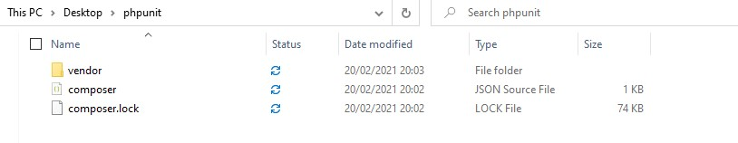

1. Switch to bin folder by typing “**cd .\vendor\bin**” and try running PHPUnit by simply writing "phpunit" in CMD.

# Manual for PHP, Composer, PHPUnit

▪ **Setting up the json and xml files for PHPUnit --**

1. Inside the phpunit or project folder create two more folders named "**tests**" and "**app**".
2. There will be a json file in your project folder named "**composer.json**" open this file and replace the codes with the following:

**{**

**"require": {**

**"phpunit/phpunit": "^5.7"**

**},**

**"autoload": {**

**"psr-4": {**

**"App\\": "app"**

**}**

**}**

**}**

1. Now, go back to CMD and write the following "**composer dump-autoload -o**".



1. After this, create a new file called "phpunit.xml" under the project folder and add the following code to it:

**<?xml version="1.0" encoding="UTF-8"?>**

**<phpunit bootstrap="vendor/autoload.php" colors="true" verbose="true" stopOnFailure="false">**

**<testsuites>**

**<testsuite name="Test suite">**

**<directory>tests</directory>**

**</testsuite>**

**</testsuites>**

**</phpunit>**

1. In CMD check if everything is working by writing “ **cd ..** ” twice and come back to the project directory" and then type “**.\vendor\bin\phpunit**” , it should show “**No tests executed!**” if it doesn't you did something wrong in the previous steps.

